PREFACE

This project of “GENERAL STORE BILLING SYSTEM” of gives us the complete information about the General Store. We can enter the record of new Products,Customers and retrieve the details of Products,Customers available in the General Store. We can sell the Products to the Customers and maintain their records and can also check how many Bills are generated from the General Store. In this project we can maintain the Products in the Store ,record of regular customers in store and total bill generated according to products brought by customers. In this project we can find the any record according any attribute like product,customer,bill nos.

Name:- Raman Verma

Content Table
S No. | Description | Page No.
1 | Intoduction | 3
1.2 | Objective | 3
2 | Project Introduction | 4
3 | Module Description | 5
3.1 | For Products
3.2 | For Customers
4 | Future Scope | 7
5 | Feasibility Analysis | 9
6 | Behavioural Feasibility | 11
6.1 | Economic Feasibility
7 | Data Flow Diagram | 12
8 | Database Design | 13
9 | Database Design Table | 14
10 | Form Snapshot | 15
11 | Testing phase | 21
12 | About the Traning | 23
13 | Conclusion | 25
13.1 | Bibliography | 25

Introduction

The project “Billing system” is an application to automate the process of ordering and billing of a “General Store store”.This application also administrates its users and customers.

OBJECTIVE

“Necessity is Mother of All Inventions”

In the current scenario record keeping and proper reporting have been the need of the hour for every transaction, including interactive interface and easy to use application, these points provided a right direction for development of this system.

My purpose in developing this application was to provide yellow page information that will be easy to navigate and operate, proper record keeping and reporting, and application that can be implemented on desktop or client/server architecture.

I have developed this system an easy to use and operate thus I assume only a familiarity with computer operation and no specific knowledge of any software, package or language.

Concepts are presented using intuitive description, many of which are based on running application at user end. Important documentation required in software development life cycle is covered in this project report, but actual codes are omitted.

This project will serve the following objectives:-

Add and maintain records of available products.

Add and maintain customer details.

Add and maintain description of new products.

Add and maintain new entered category of products.

Provides a convenient solution of billing pattern.

Make an easy to use environment for users and customers.

System design and Development was integrated into different modules such as:

- Login Module
- Add/delete/update Customers Details
- Add/delete/update Products Details
- Make bill
- Search Billing Informations
1- By Customers
2- By Bills

Project category

RDBMS:
The project is based on the concept of RDBMS (i.e. Relational Database Management System).

“ A database which store data in the form of tables which has related with each other in as particular manner ”.

PROJECT INTRODUCTION

This Project General Store Billing System is to design a Software. This software is developed in Core Java and Back End of this software is MS Access. Which facilitates General store product and customers data for billing. This project has following modules:-

PROJECT MODULE:
Operational and Functional Procedural Description

The complete system is developed using modular development technique. The task is divided into four major modules, namely:

- Login
- Add/delete/update Customers Details
- Add/delete/update Products Details
- Make bill
- Search Billing Informations
- By Customers
- By Bills
- Print the bill

Module description is given below :

For Products

Login Module: This module takes user name and password. This module validates username and password.
Input parameter : user name, password
Output parameters : Permission Accepted / Denied

Add Entry Module : This process is used to add the new id subscribed to product and updates the database accordingly.
Input parameter : id,name,price,quantity,discount,brand
Output parameters : entry added to database

Delete Entry Module : This process is used to erase the numbers that are deleted by Administrator and updates the database accordingly.
Input parameter : id
Output parameters : entry deleted from database

Modify Entry Module : This process is used to change any record already present in the database and updates the database accordingly.
Input parameter : id,name,price,quantity,discount,brand
Output parameters : entry added to database

Search module : This module provides flexibility to user for searching the list of Store.

- By PNo :- In this module user has to enter the number which in result returns the details of Product.
- By Name:-In this module customer has to enter the name which in result returns bill details.
3. By Price between :- In this module user has to enter the price within limit which in result returns the details of product within that limit.

Input parameters – Name, Price,Quantity,Brand.
Output parameters – Bill Details.

For Customers

Login Module: This module takes user name and password. This module validates username and password.
Input parameter : user name, password
Output parameters : Permission Accepted / Denied

Add Entry Module : This process is used to add the new id subscribed to customer and updates the database accordingly.
Input parameter : id,name, address, phone
Output parameters : entry added to database

Delete Entry Module : This process is used to erase the numbers that are deleted by Administrator and updates the database accordingly.
Input parameter : id
Output parameters : entry deleted from database

Modify Entry Module : This process is used to change any record already present in the database and updates the database accordingly.
Input parameter : id,name, address, phone
Output parameters : entry added to database

Search module : This module provides flexibility to user for searching the list of Store.

- By Mobile Number :- In this module user has to enter the mobile number which in result returns the details of customer’s bill.
- By Name:-In this module customer has to enter the name which in result returns bill details.
3. By Phone Number :- In this module user has to enter the phone number which in result returns the details of customer’s bill.

Input parameters – Name, Mobile Number, Phone Number.
Output parameters – Bill Details.

Scope of Project:
This software is developed specifically to shopkeepers to manage the product in the Store. It is totally self contained and works efficiently. It provides simple database rather than complex ones for high requirements and it provides good and easy graphical user interface to both new as well as experienced user of the computer.
The project will be supposed to implement the storage of Guest Details so that a large collection could be maintained with minimum storage space.

Future Scope
1. This project will help the store keeper in fast billing
2. This project enable store keeper to maintain a great database of all customers visited and purchase product from store.
3. Project will enable to see report regarding product and category.
4. Easy to maintain in future prospect.

ANALYSIS OF PRESENT SYSTEM
Before we begin a new system it is important to study the system that will be improved or replaced (if there is one). We need to analyze how this system uses hardware, software, network and the people resources to convert data resources, such as transaction data, into information products, such as reports and displays. Thus we should document how the information system activities of input, processing, output, storage and control are accomplished.

PROBLEM OF EXISTING SYSTEM
- Inability of modification of data: The managing of huge data effectively and efficiently for efficient results, storing the details of the consumers etc. in such a way that the database can be modified as not possible in the current system.
- Not user friendly: The existing system is not user friendly because the retrieval and storing of data is slow and data is not maintained efficiently.
- Difficulty in reports generating: Either no reports generating in a current system or they are generated with great difficulty reports take time to generate in the current system.
- Manual operator control: Manual operator control is there and lead to a lot of chaos and errors.
- Lot of paperwork: Existing system requires lot of paper work and even a small transaction require many papers fill. Moreover any unnatural cause (such as fire in the organization) can destroy all data of the organization. Loss of even a single paper led to difficult situation because all the papers are interrelated.
- Inability of sharing the data: Data cannot be shared in the existing system. This means that no two persons can use the same data in existing system. Also the two departments in an organisation cannot interact with each other without the actual movement of data.
- No support in decision-making: Existing system does not support managerial decision-making.
- No support in strategic competitive advantage: Existing system do not support strategic competitive advantages.

CHARACTERISTIC OF THE PROPOSED SYSTEM
1. Easiness in modification of data: The proposed system provides managing of huge data effectively and efficiently for efficient results, storing the details of the customers, employees etc. in such a way that the database can be modified.
2. User friendly: The proposed system is user friendly because the retrieval and storing of data is fast and data is maintained efficiently. Moreover the graphical user interface is provided in the proposed system,
which provides user to deal with the system very easily.
3. Reports are easily generated: Reports can be easily generated in a proposed system. So any type of reports can be generated in a proposed system, which helps the managers in a decisions-making activity.
4. Sharing the data is possible: Data can be shared in proposed system. This means that two or more persons can use the same data in existing system provided that they have right to access that data. Also the two or more departments in an organisation can easily interact with each other without the actual movement of data.
5. No or very few paperwork: The proposed system either does not require paper work or very few paper works is required. All the data is feted into the computer immediately and various bills and reports can be generated through computers. Since all the data is kept in a database no data of the organisation can be destroyed. Moreover work becomes very easy because there is no need to keep data on papers.
6. Support strategic competitive advantage: Proposed system supports strategic competitive advantages. Since the proposed systems provide easiness in reports generating it will provide strategic advantages among competitors.
7. Computer operator control: Computer operator control will be there no errors. Moreover storing and retrieving of information is easy. So work can be done speedily and in time.

FEASIBILITY ANALYSIS
NEED FOR FEASIBILITY STUDY
The feasibility study is carried out to test whether the proposed system is worth being implemented. Feasibility study is a test of system proposed regarding its work ability, its impact on the organisation ability to meet user needs and effective use of resources. It is usually carried out by a small number of people who are familiar with the information system techniques, understand the part of the business or organisation that will be involved or effected by the project and are skilled in the system analysis and design process.
The key consideration involve in the feasibility study are:
- Technical
- Behavioural
- Economic

1. TECHNICAL FEASIBILITY
Technical feasibility centres on the existing computer system ( hardware, software etc ) and to what extent it can support the proposed system addition. For example, if the current system is operating at 70% capacity ( an arbitrary value ), then another application could overload the system or require additional hardware. If the budget is serious constrain then the project is judged not feasible.
The technologies ant the environment which are used in this project are
1.2 EQUIPMENT AND TOOLS REQUIRED AND PLANNING OF ARRANGEMENTS:
Planning for the development of General Store Billing System has been done through the honourable project guide. We applied brainstorming method by my own. I adopted the most favourable suggestions. Web search plays a vital role and documents enhanced the reposts all done as per guidance of the project guide. I studied the HTML, JAVA and MS Access to develop this site.
1.2.1 Equipment Required:- Well equipped laptop or computer with latest configuration connected with Printer.
1.2.2 Hardware Requirements:- To develop the project we require the following hardware and softwares.

1.2.3 Hardware Requirement at Development Site
The application would be developed in:
- Intel Dual Core 2.5 GHz Processor
- 100 GB HD
- Minimum 512 MB RAM
- Standard USB Keyboard and Mouse
- Window-7 or Above
- Printer
1.2.4 Hardware Requirement for the End Users: -
Following Hardware configuration is recommended for end user proper working of the project.
- Minimum Intel Dual Core 2.5 GHz Processor.
- Minimum 1 GB RAM
- Window XP SP2 or Above, Window-7
- 180 GB Hard Disk Storage Space
- Stand Keyboard and Mouse
1.2.5 Software Requirements Development Site:-
- Operating System: Window XP PS Pack 2 or Above
- Front End Programming : - JAVA
- Back End Database : - MS Access
1.2.6 Software Requirement bye End Users: -
- Operating System: Window XP PS Pack 2 or Above

2. BEHAVIOURAL FEASIBILITY:

An evaluation of the behaviour of the end users, which may effect the envelopment of the system. People are inherently resistant to change and computers have to know to facilitate changes and computers have to known to facilitate changes. An estimate should be made of how strong a reaction the user staff is likely to have towards the development of a computerised system. It is a common knowledge that a computer installation has something to do with turnover, transfer, retraining and changes in employee job status, therefore the introduction of a candidate system requires special effort to educate, sell and train the staff on new ways of conducting business.
The personal of the user organisation will be affected by the proposed system. As the aim of the system is only to satisfy the information needs, no employees will loose their position by the proposed system. In fact the proposed system will help the organisation in reducing the voluminous work involved. Also the involvement of users in every stage of the project is going to increase the success factor.
The staff in not well educated for running a computerised system. They are adamant in perceiving a mechanical process of working as they have long been used to the manual entry system. This aspect needs considerable amount of attention.
Our system is also feasible for organisation because it supports of the organisation and its strategic plan.
3. ECONOMIC FEASIBILITY:
The procedure is to determine the benefits and savings that are expected from a candidate system and compare it with the costs. If a benefit outweighs costs, then the decision is made to design and implement the system. Otherwise further alterations are made in the proposed system
1. Manpower cost
2. Hardware and software cost

Data Flow Diagram

A data flow diagram is graphical representation that depicts the information flow and the transforms that r applied as date moves from input to output. It can be used to represent a software at any level of abstraction. In fact DFDs may be partitioned in to levels. That represents increasing information flow and functional details.
DFDs are defined in levels with every level decreasing the level of abstraction as well as defining a greater detail of the functional organs of the system. A zero level DFD also known as context or fundamental system model represents the entire software elements as a single bubble with input and output data entities which are indicated as incoming and outgoing arrows. Data Flow Diagram help understanding the basic flow of data from one process to another process. This 0 level DFD represents fundamental overview of the billing system.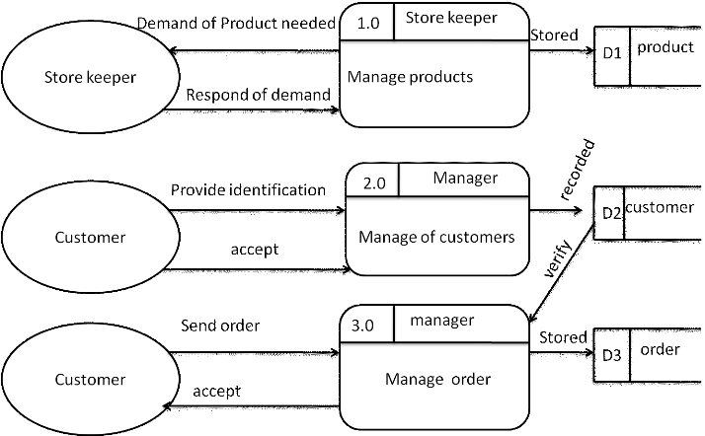Work Flow

Work in the Supermarket will be done in the following way:
1. The product will come in the store.
2. Data entry operator will enter the information of the product in
database.
3. The Administrator will enter the taxes and commissions for each
product.
4. The customer will come and take the basket with him/her and choose
the product and took it to the counter.
5. The bill calculating operator will check the products with the bar code
detecting machine then it will match with product-id then it will show
its information and price and the bill will be calculated and total
payment will shown.
6. Customer will pay for the products.
7. All the products will be packed and delivered to the customer.

DATABASE DESIGN
1. NORMALIZATION
A Database is a collection of interrelated data stored with a minimum of redundancy to serve many applications. The Database design is used to group data into number of tables and minimizes the artificiality embedded in using separate files. The tables are organized to:
- Reduce duplication of data.
- Simplify functions like adding, deleting, modifying, data etc….
- Retrieving data.
- Clarity and ease of use.
- More information at low cost.

Normalization
Normalization is built around the concept of normal forms. A relation is said to be in a particular normal form if it satisfies a certain specified set of constraints on the kind of functional dependencies that could be associated with the relation. The normal forms are used to ensure that various types of anomalies and inconsistencies are not introduced into the database.
First Normal Form:
A relation R is in first normal form if and only if all underlying domains contained atomic values only.
Second Normal Form:
A relation R is said to be in second normal form if and only if it is in first normal form and every non-key attribute is fully dependent on the primary key.
Third Normal Form:
A relation R is said to be in second normal form if and only if it is in first normal form and every non-key attribute is non-transitively depend on the primary key.

DATABASE DESIGN TABLE
CUSTOMERS
CID | Int(Primary key)
Name | Varchar
Gender | Varchar
Address | Varchar
Area | Varchar
Pincode | Int
EmailId | Varchar
ContactNo | Varchar

PRODUCTS
PID | Int(Primary key)
Name | Varchar
Brand | Varchar
MRP | Int
Quantity | Int
Unit | Varchar
Discount | Int

BILLING
SNo | Int(Primary key)
PID | Int(Foreign key)
CID | Int(Foreign key)
BillNo | Int
PurchaseDate | Varchar
Price | Int
Quantity | Int

Form Snapshots
1.Relationship between Tables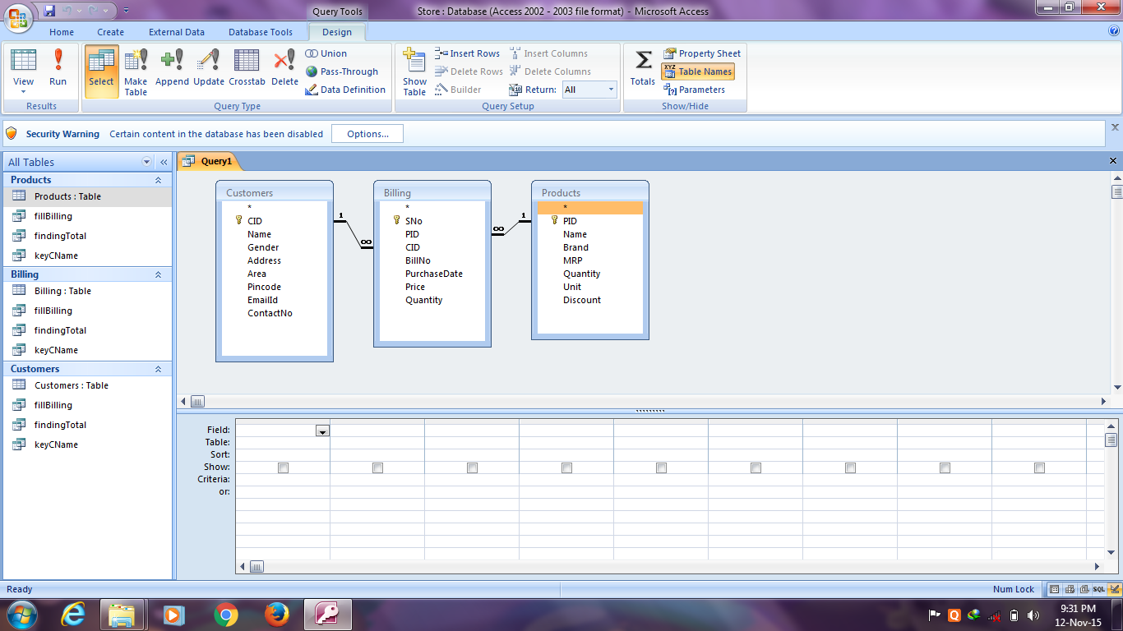
2. Login Panel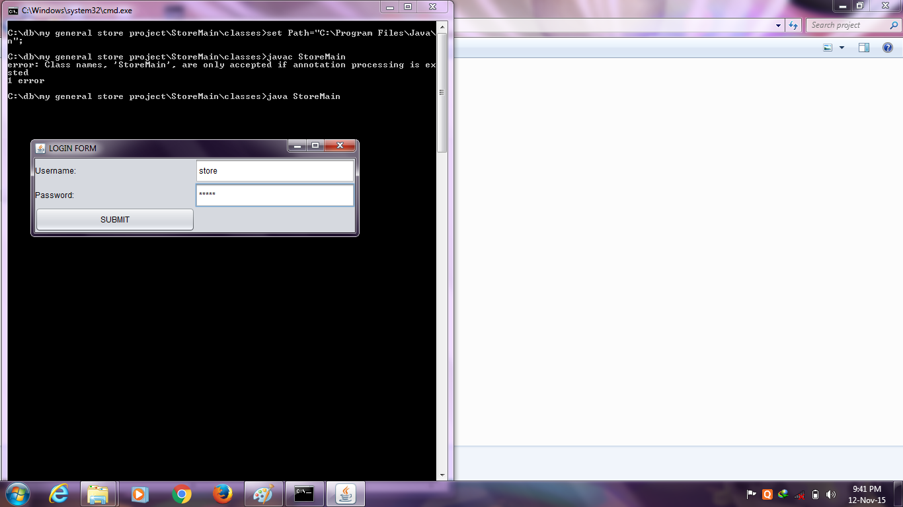
3. Main Panel of the Project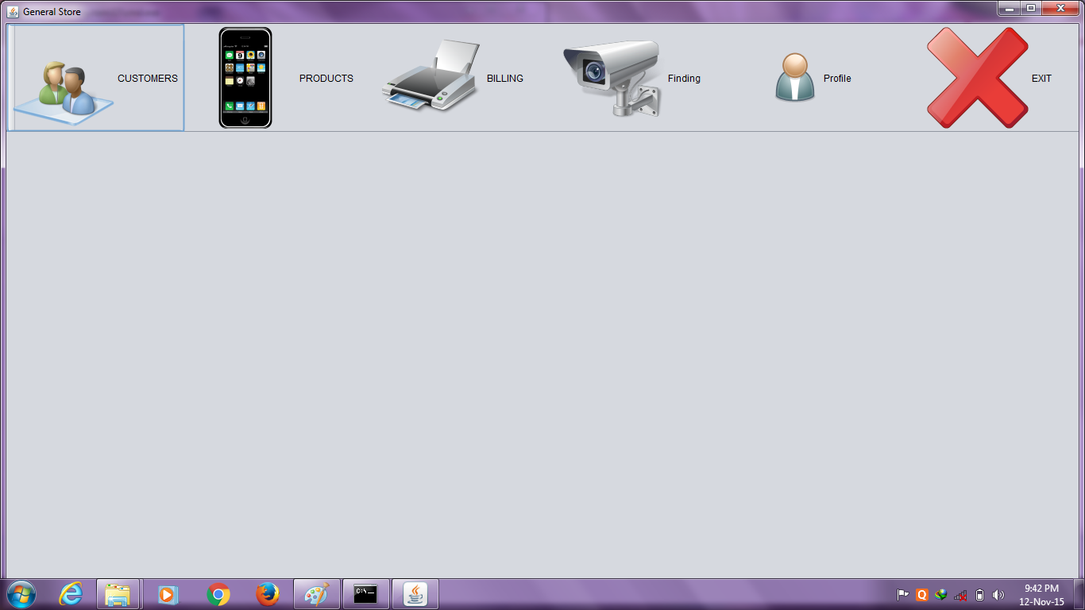
4. Customer Panel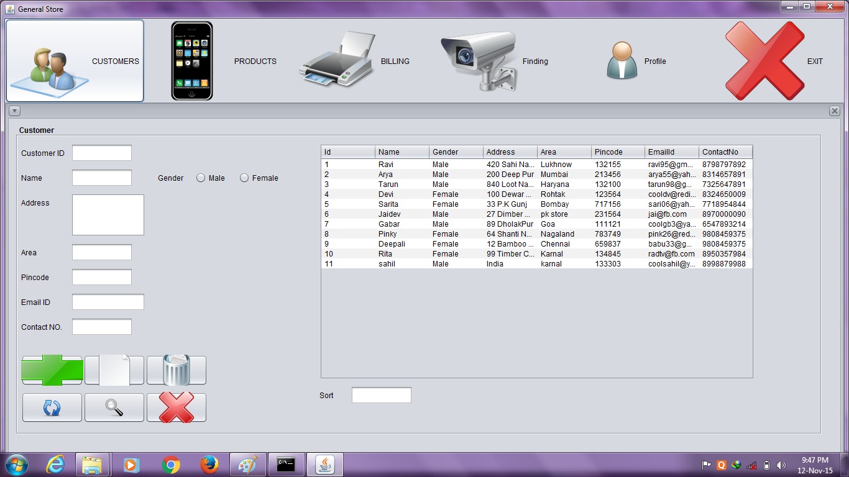
5. Product Panel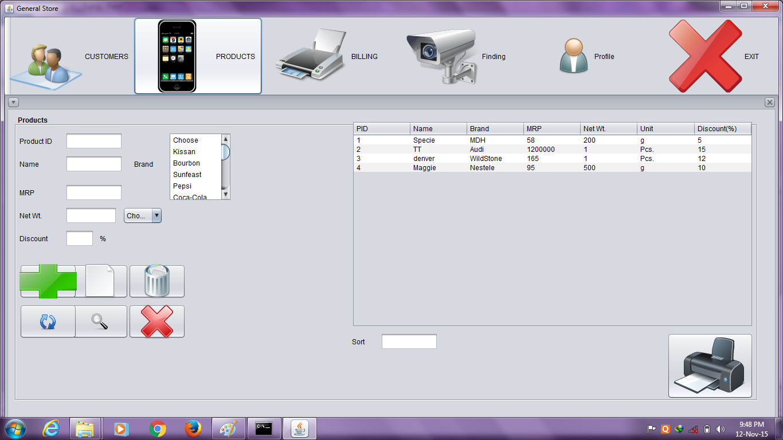
6. Billing Panel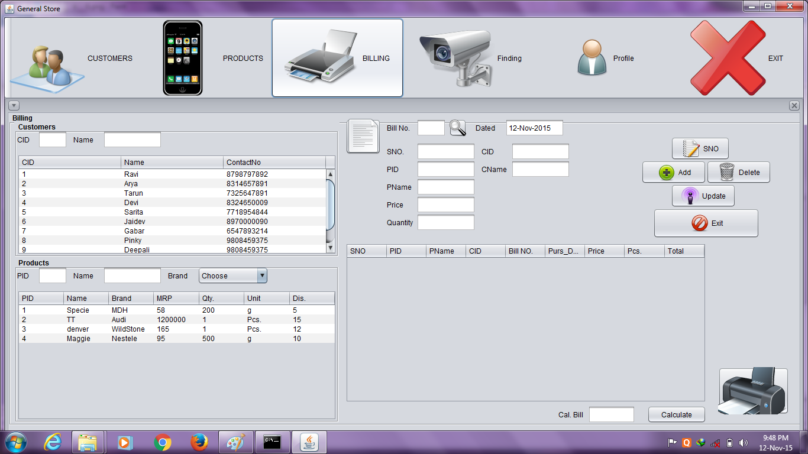
7. Generate Bill according to Customer 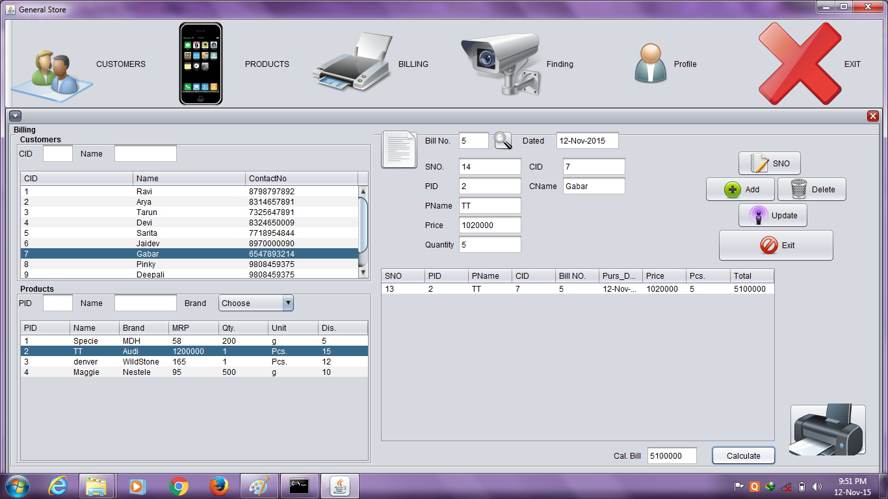
8. Searching according to Customer Details 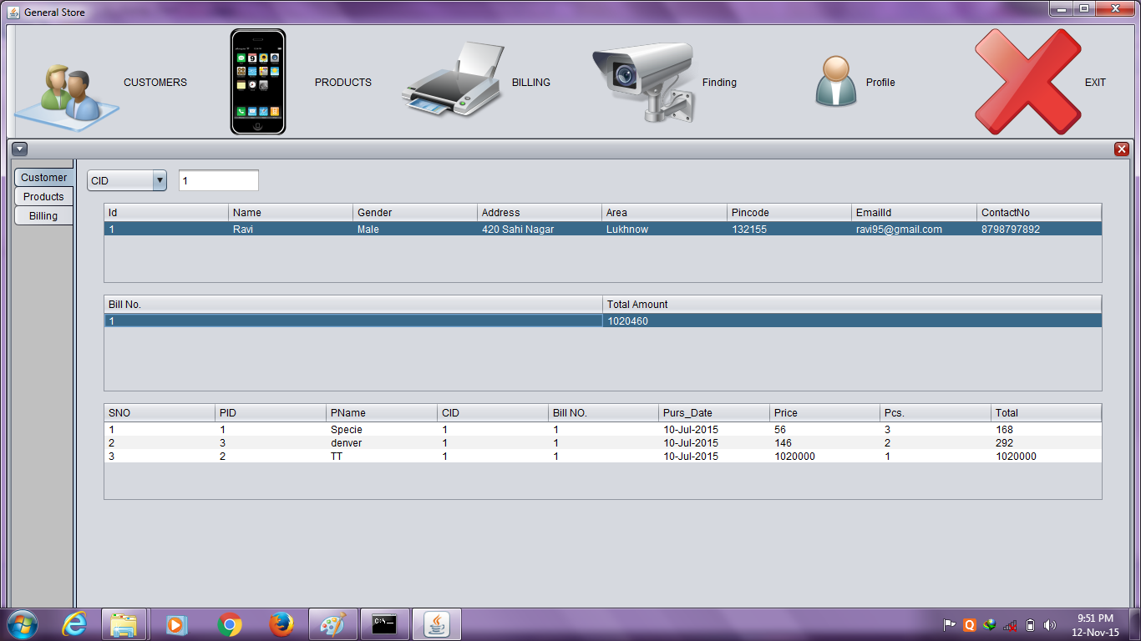
9. Searching according to Products Details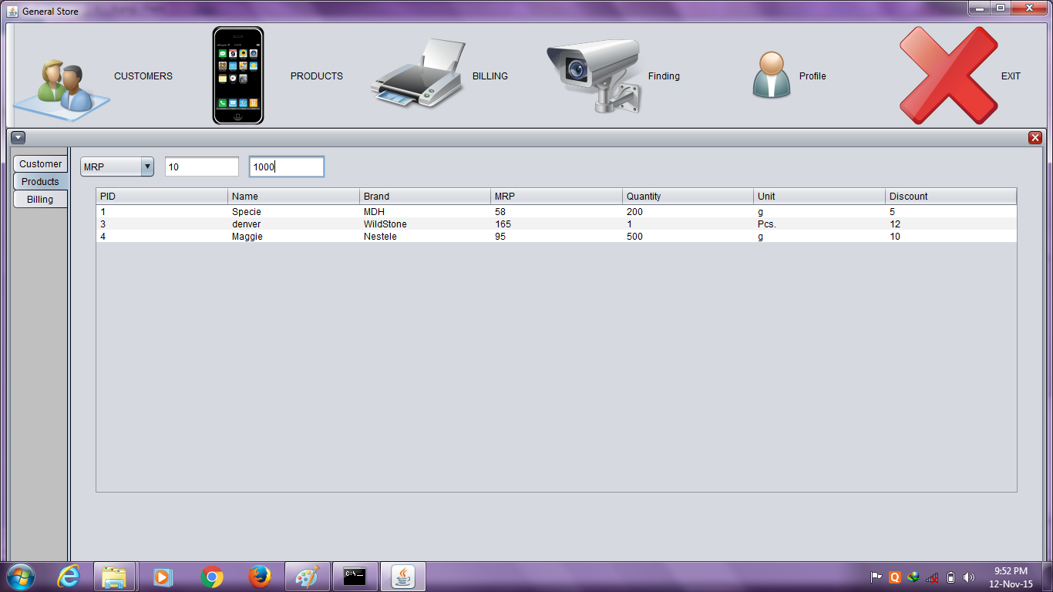
10. Searching according to Billing Details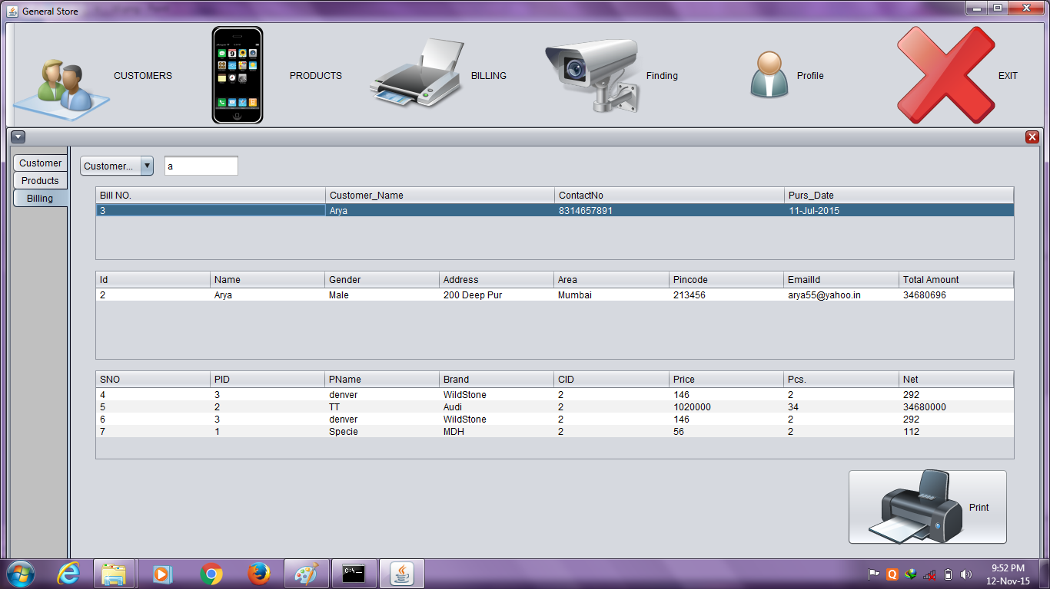
11. Information About the Developer of the Project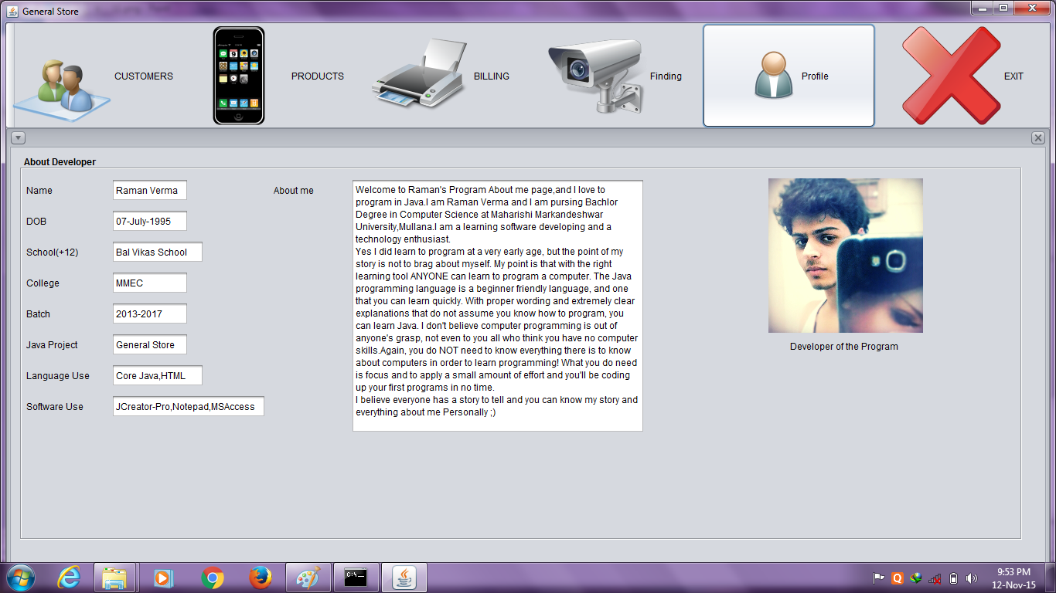12. Printed Bill 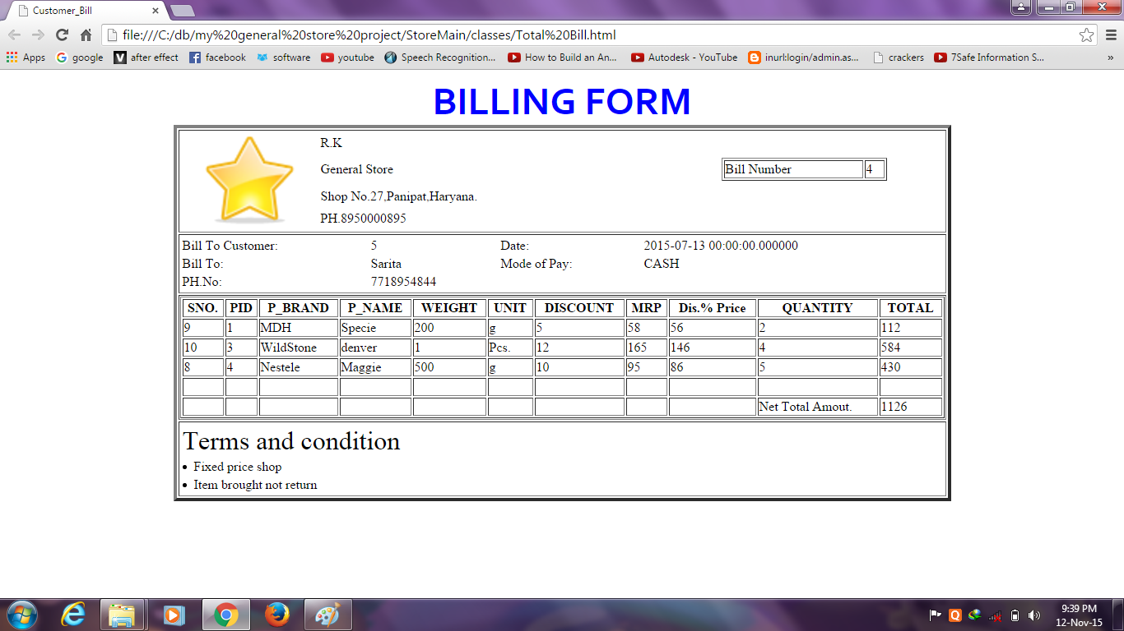

TESTING PHASE
Testing is a vital to success of project. Project testing makes a logical assumption that if all the parts of the project are correct, the goal will be successfully achieved .Inadequate testing or non-testing leads to errors that may not appear until months later.
A small system error can conceivably explode into a much larger problem. Effective testing early in the process translates directly into long term cost savings from a reduced number of errors. Another reason for project testing is its utility as a user –oriented vehicle before implementation .The best program is worthless if it does not meet user needs. Unfortunately, the user’s demands are often compromised by efforts to facilitate program or design efficiency in terms or memory utilization.
Testing plays a critical role in quality assurance for software. Due to the limitation of the verification method for the previous phases, design and requirement fault also appear in the code. Testing is used to detect these errors, in addition to the error introduced during coding phase.

Testing is a dynamic method for verification and validation, where the system is to be tested is executed and behavior of the system is observed. Due to this testing the failure of the system can be observed, from which the presence of fault can be deduced. However, separate activities have to be performed to identify the faults.
There are two method of testing:
- Functional
- Structural

In functional testing, the internal logic of the system under testing is not considered and the test cases are decided from the specification or the requirements. It is often called “Black Box Testing”
In structural testing, the test cases are decided entirely on the internal logic of the program or module being tested.

The basic steps of testing have been picked from software engineering practices. The following are the steps, we undertook:
- The content of the Intranet site is reviewed to uncover Content errors. Content Errors covers the typographical errors, grammatical errors, errors in content consistency, graphical representation and cross referencing errors.
- The design model of the web application is reviewed to uncover the navigation errors. Use cases, derived as a part of the analysis activity allows a web designer to exercise each usage scenario against the architectural and navigational design. In essence these non-executable tests help to uncover the errors in navigation.
- When web applications are considered the concept of unit changes. Each web page encapsulates content navigation links, content and processing elements (Forms, Scripts in our case). It is not always possible to test each of these individually. Thus is the base of the web applications the unit to be considered is the web page. Unlike the testing of the algorithmic details of a module the data that flows across the module interface, page level testing for web applications is driven by content, processing and links encapsulating the web page.
- The Assembled web application is tested for overall functionality and content delivery. The various user cases are used that test the system for errors and mistakes.
- The Web application is tested for a variety of environmental settings and is tested for various configurations and upon various platforms.

9.1 TESTING OBJECTIVES:
The main objective of testing is to uncover a host of errors, systematically and with minimum effort and time. Stating formally, we can say,
1. Testing is a process of executing a program with the intent of finding an error.
- A successful test is one that uncovers an as yet undiscovered error.
- A good test case is one that has a high probability of finding error, if it exists.
- The tests are inadequate to detect possibly present errors.
- The software more or less confirms to the quality and reliable standards.

9.2 LEVELS OF TESTING
In order to uncover the errors present in different phases, we have the concept of levels of testing. The basic levels of testing are:

Client Needs Acceptance Testing

Requirements System Testing

Design Integration Testing

Code Unit Testing

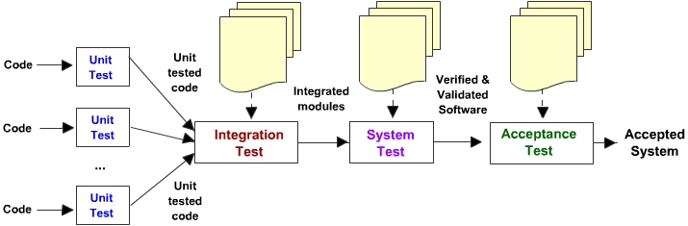
ABOUT THE TRAINING

- OBJECTIVE ANALYSIS
This stage specifies the problem definition that is it identifies the specific problem to be solved.

- REQUIREMENT ANALYSIS
The requirement gathering process is intensified & focused specifically on software. To understand the nature of the program to be built, we must understand the information domain for the software, as well as the required function, behavior, performance and interface. Requirements for both the system & the software are documented and reviewed with the customer.

3. DISCUSSION WITH PROJECT GUIDE AND PROJECT HEAD
As this is the very first time we are preparing any project ,so we have made our project under the guidance of our project in charge & faculty of computer science.

4.ANALYSIS OF INFORMATION
In these stage models of the system is created in an effort to better understand data & control flow ,functional processing ,operational behaviour & information content .The model serves as a foundation for software design.

5. COMPARING WITH AN EXISTING SYSTEM
The system model which is analyzed is compared with real life or existing system so that if there is any thing which is not present in our system model is provided in it.

6. DESIGNING
Software design is an iterative process through which requirements are translated into a “blueprint” for constructing the software .Software design is actually a multistep process that focuses on four distinct attributes of a program data structure ,software architecture ,interfaces representation & procedural (algorithmic) details.

7 .CODING CUSTOMER CARE
The design must be translated into a machine readable form. The code generation step performs this task & we provide the actual code .

- REVIEWING AND TESTING
Once code has been generated, program testing begins. The testing process focus on the logic of the software , ensuring that all statements have been tested and on the functional externals ,that is ,conducting test to uncover errors and ensure that define input will produce actual result that agree with required result.

9. SUBMISSION OF PROJECT REPORT
Once system is tested ,project report is made and submitted to project in charge.

Conclusion

Our project is on General Store Billing System. We have successfully completed it. We take this opportunity to express our sense of indebtedness and gratitude to all those people who helped us in completing this project. We are immensely grateful to our esteemed faculty guide Assistant Mr. Manoj Jangra and other faculties for their supervision and guidance without which this work would not have been possible. This project has contributed a lot to my knowledge that has proved to be a value addition for me.

BIBLIOGRAPHY
1. The Complete Reference (Java)
2. Web Searched

